# Square Brackets (2)

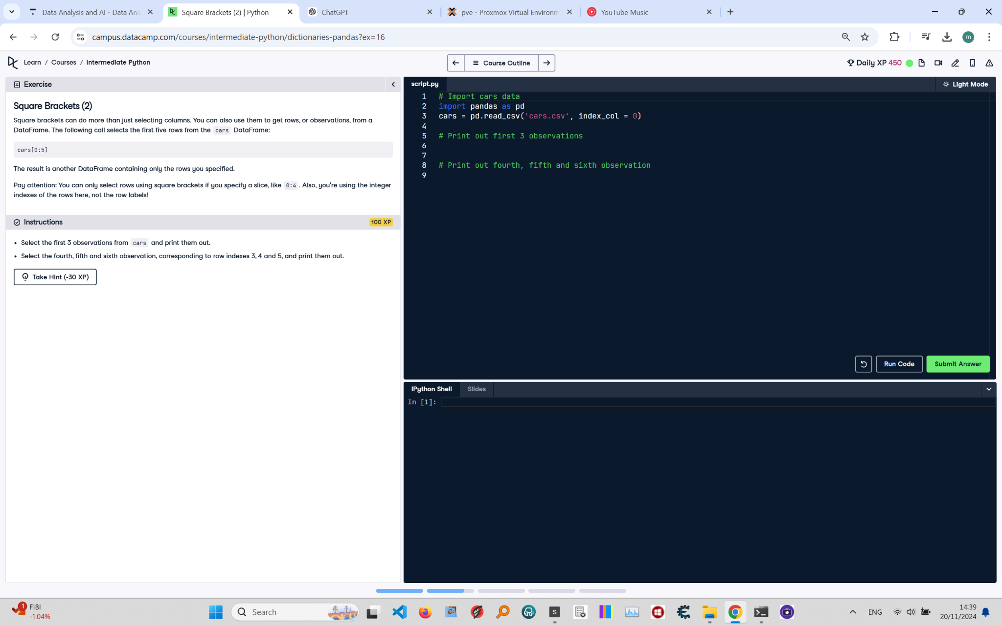

## Instructions:

1. Select the first 3 observations from cars and print them out.  
2. Select the fourth, fifth, and sixth observations, corresponding to row indexes 3, 4, and 5, and print them out.

## Code and Explanation:

# Import cars data  
import pandas as pd  
cars = pd.read_csv('cars.csv', index_col=0)  
  
# Print out first 3 observations  
print(cars[0:3])  
  
# Print out fourth, fifth, and sixth observation  
print(cars[3:6])

Explanation of the Code:  
1. The 'cars.csv' file is read into a Pandas DataFrame using pd.read_csv with index_col=0 to set the first column as the index.  
2. The slicing 'cars[0:3]' selects the first 3 rows (index positions 0, 1, and 2).  
3. The slicing 'cars[3:6]' selects the rows with index positions 3, 4, and 5.